

Semester End Project: PHP & MYSQLI

PROJECT NAME: VAX-REGISTERY

|  |  |  |
| --- | --- | --- |
| Serial No: | Developers | Batch |
| 1 | Muhammad Hassan | 2308e |
| 2 | Sajan Kumar | 2308e |
| 3 | Abdul Qayyum | 2308e |
| 4 | Muhammad Sufiyan | 2308f |

Vax-Registry Vision:

At Vax-Registry, our vision is to revolutionize vaccine management by providing an innovative, comprehensive, and user-centric system that enhances public health and safety. We strive to empower healthcare providers and patients through seamless access to vaccination.

information, improving efficiency and communication across the healthcare ecosystem.

About Index Page:

We Provide in index page Homepage, About Us, Contact Us, and Account section.



Contact us page:

In contact us section contact with form and Location and chats

Section:

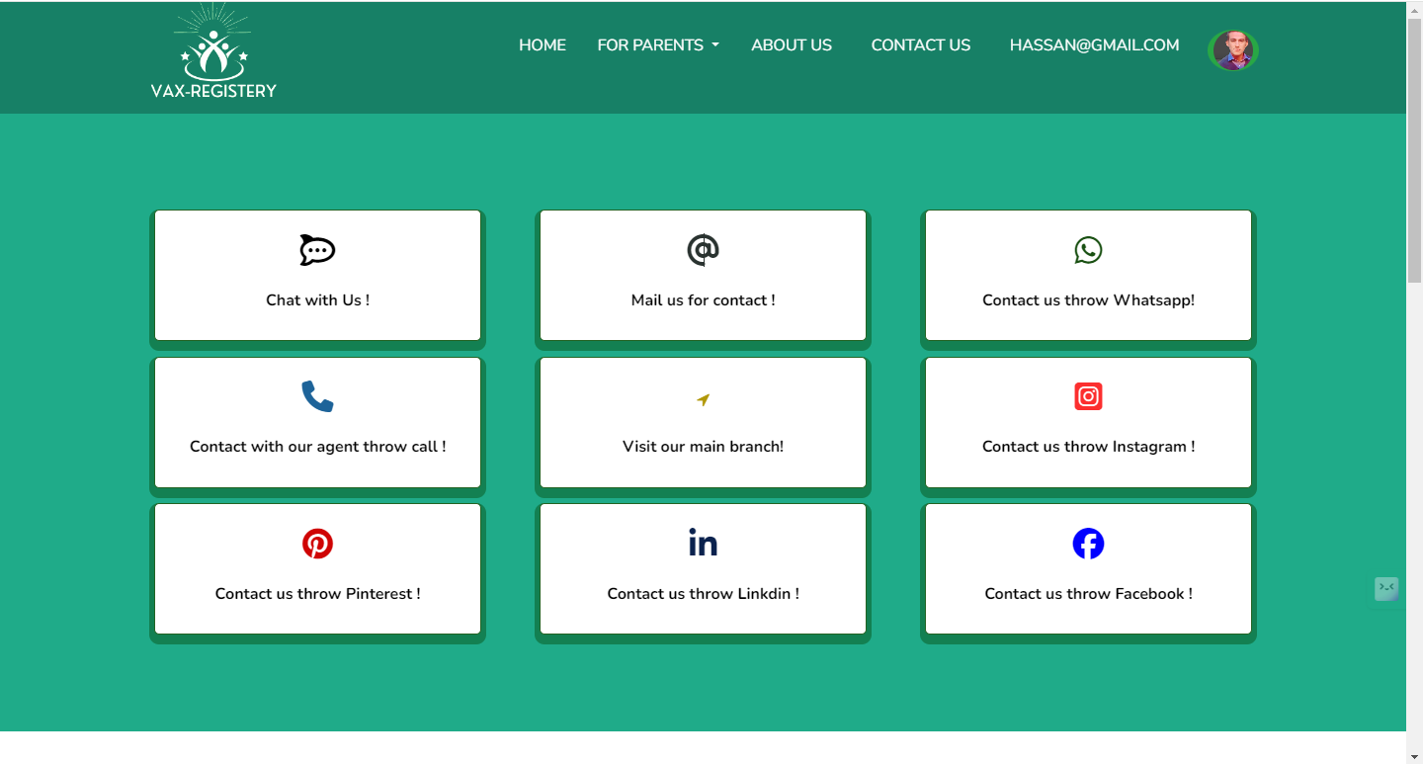

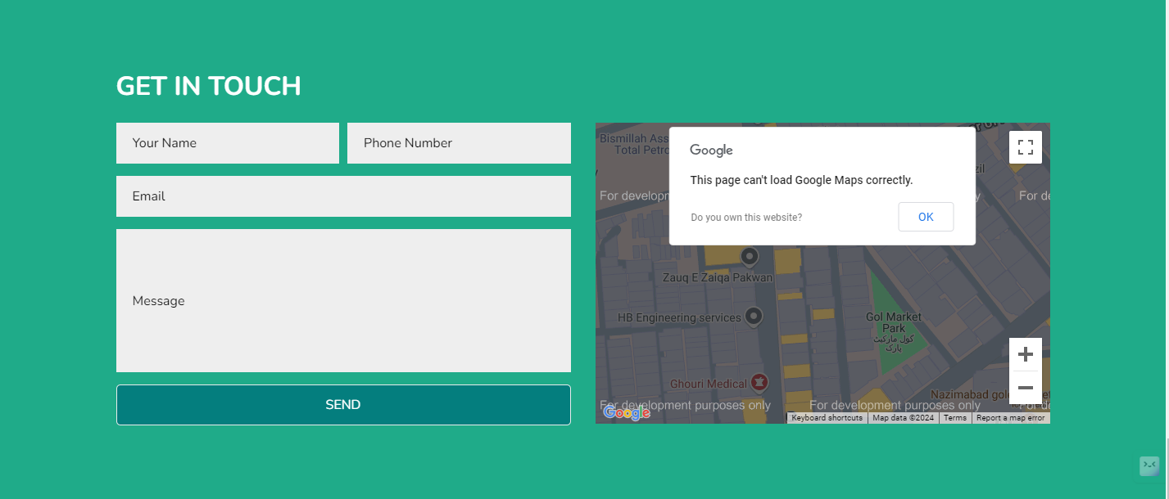

About us Page:

This page contains 2 sections Our Team and about us text.





About Account page:

Our account section page contains in 3 sections:

Admin Login:

Patient Login & Register:

Hospital login & and Register:

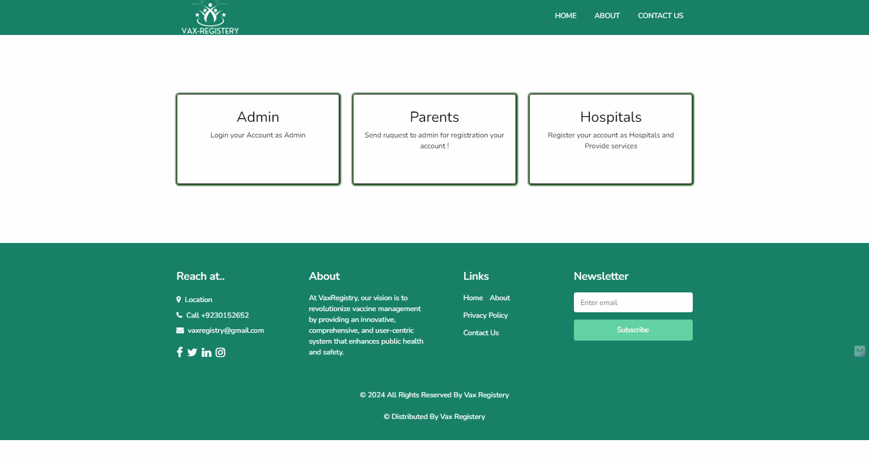

Admin Section:

Admin section contains useful links and All Details of Patients and Hospitals Data:

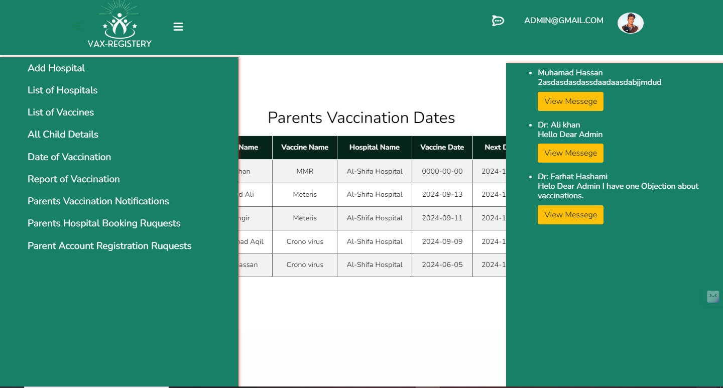

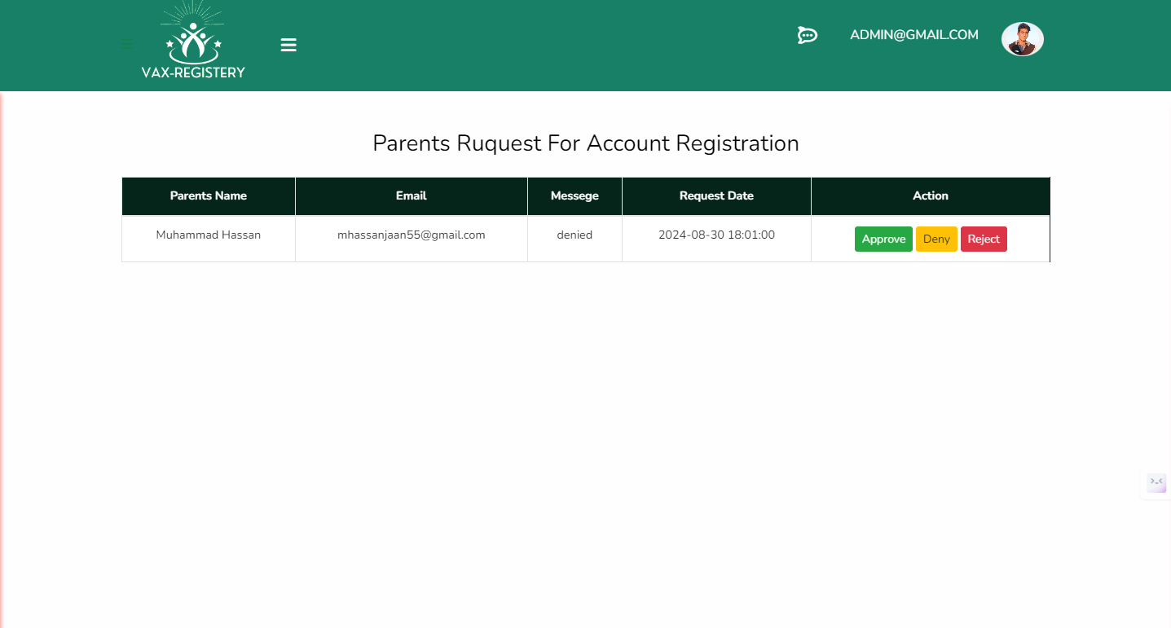

Admin All Hospital Details:

This page contains all hospital registration and vaccine details:

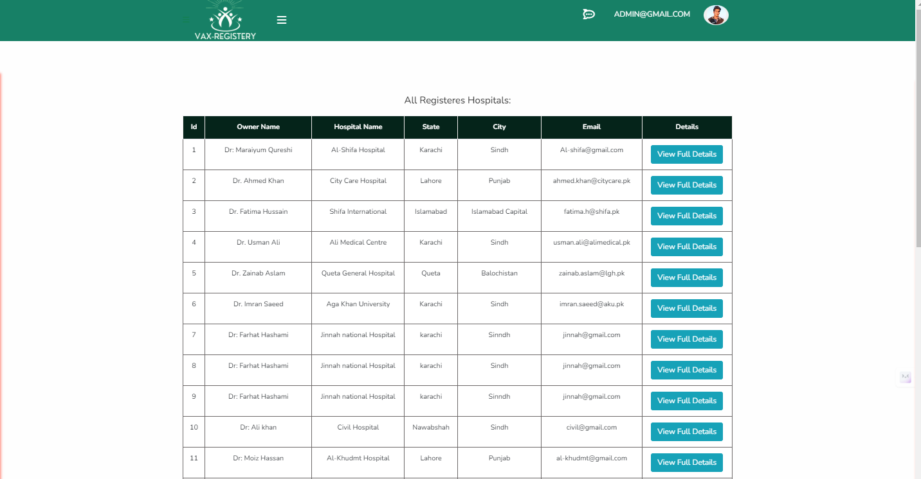

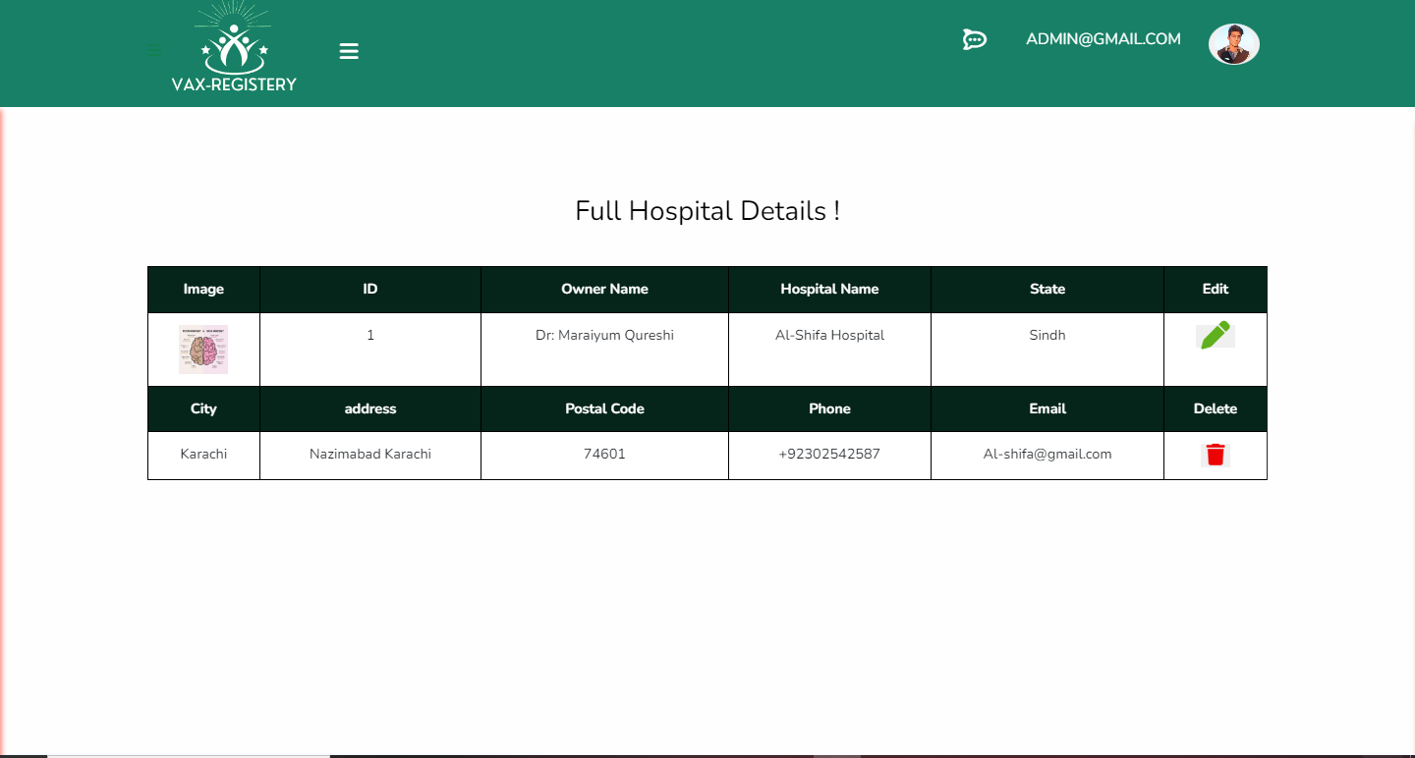

Admin Details:

All details Doctors, vaccines, Vaccinated Child’s, Booking requests.

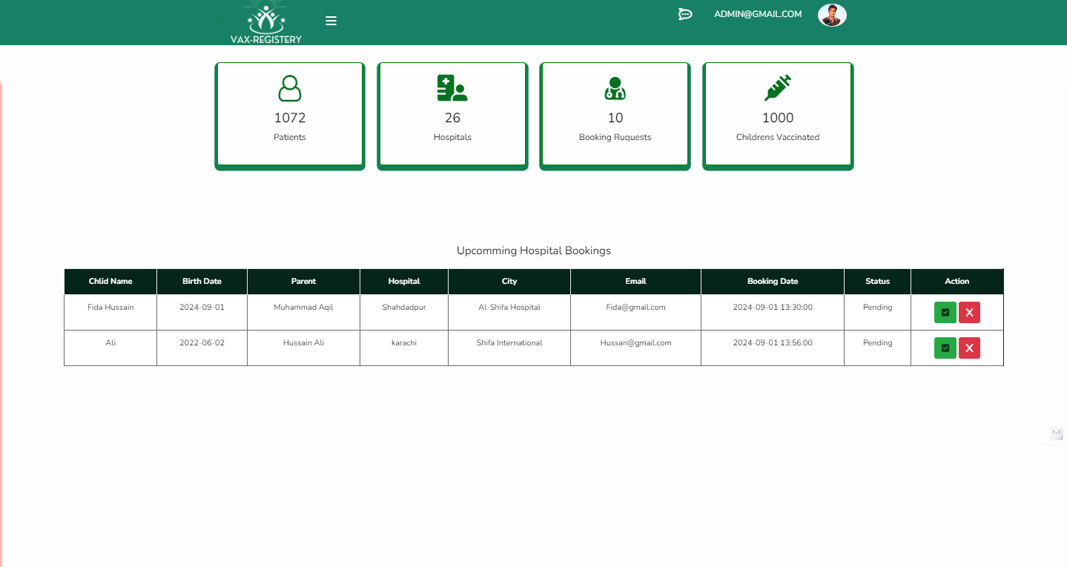

Admin All Vaccine Child’s Report:

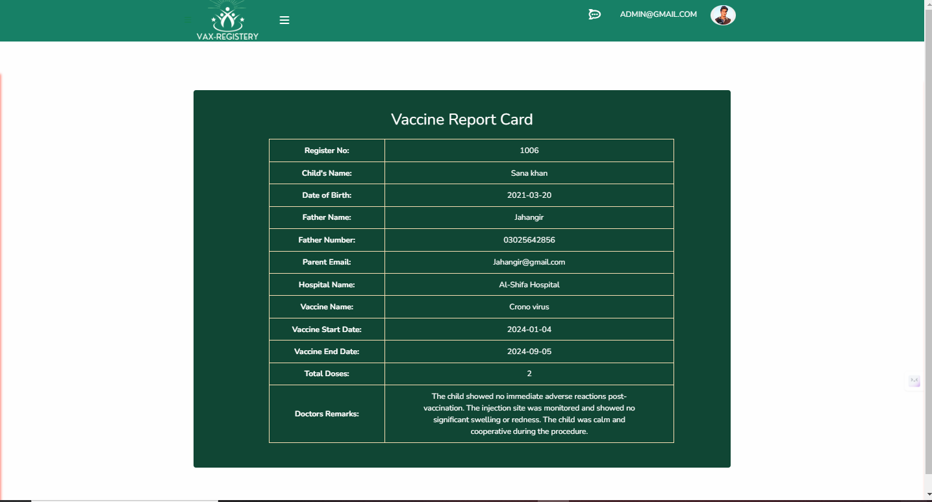

Hospital Section:

Hospital section page contains:

Login & Register:

Update Vaccine Status:

Hospital Gallery:

Hospital Home Page:



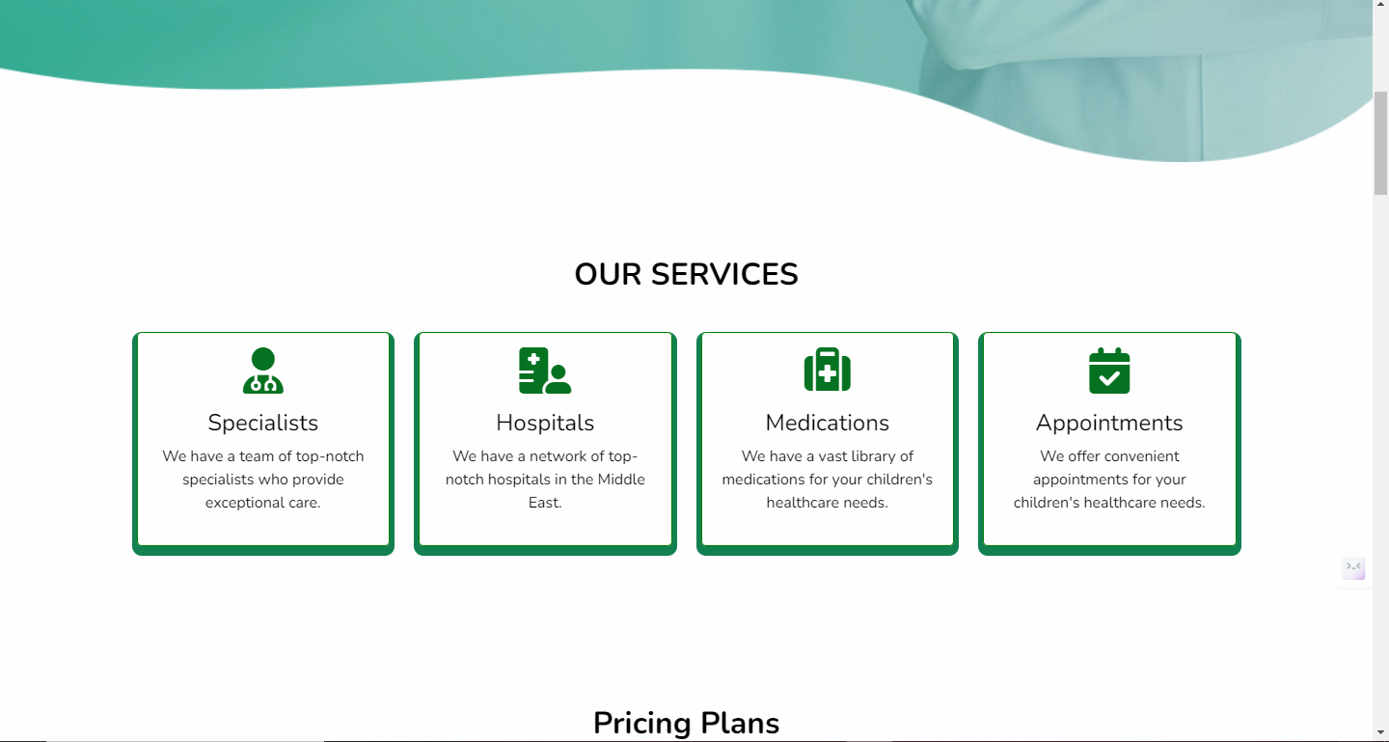

Hospital Child’s vaccine data and vaccine list:

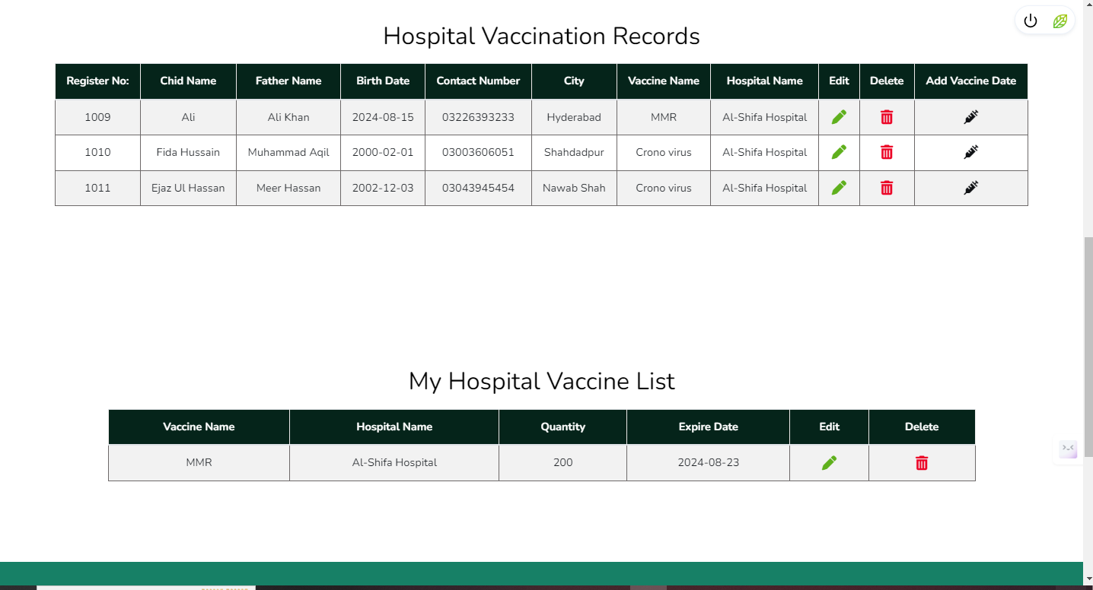

Parent’s Section:

Parents section contains:

Details of child’s:

Child’s vaccination dates:

Book Hospital:

Find Hospitals:

Report of vaccination taken:

Parents Homepage:



Vaccines Status for Parents from Hospitals:

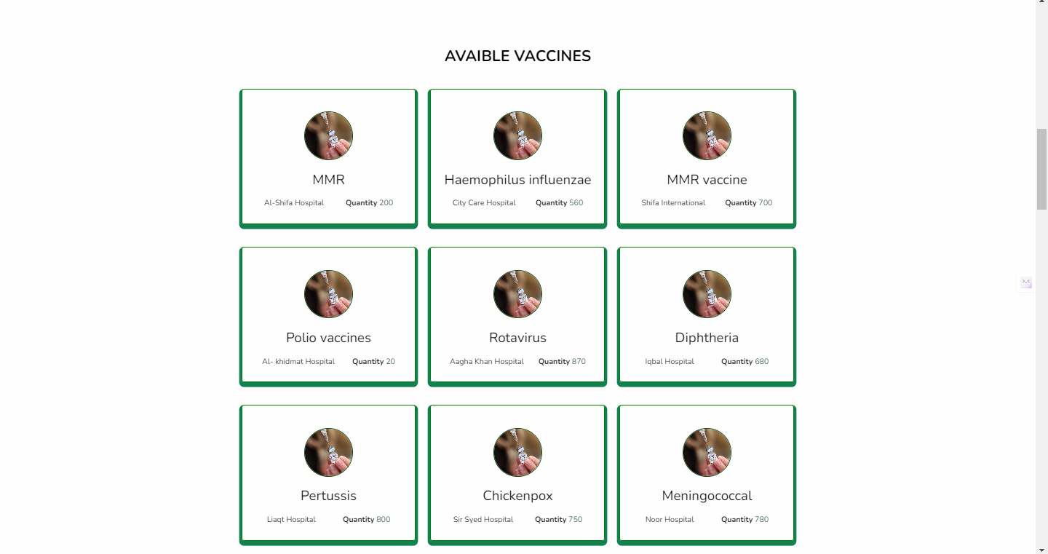

Find Hospitals for Parents:



Parents Vaccination Dates: ￼

Parents Book Hospitals Information:



Parents Book Hospitals Form

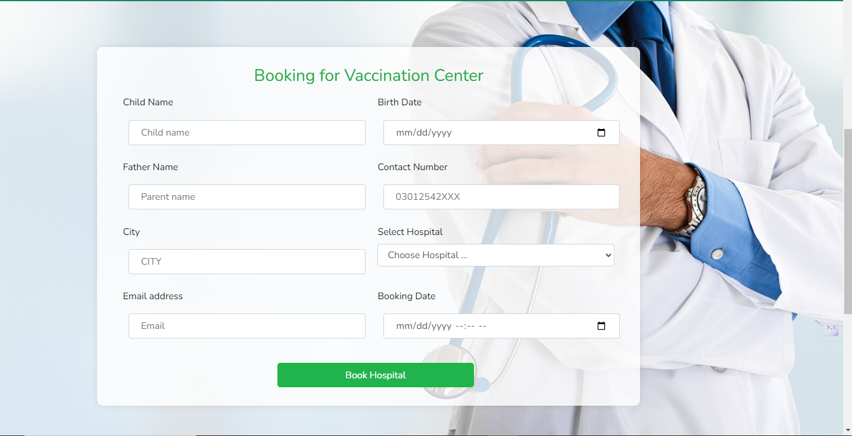

Parents Hospitals Bookings Request:

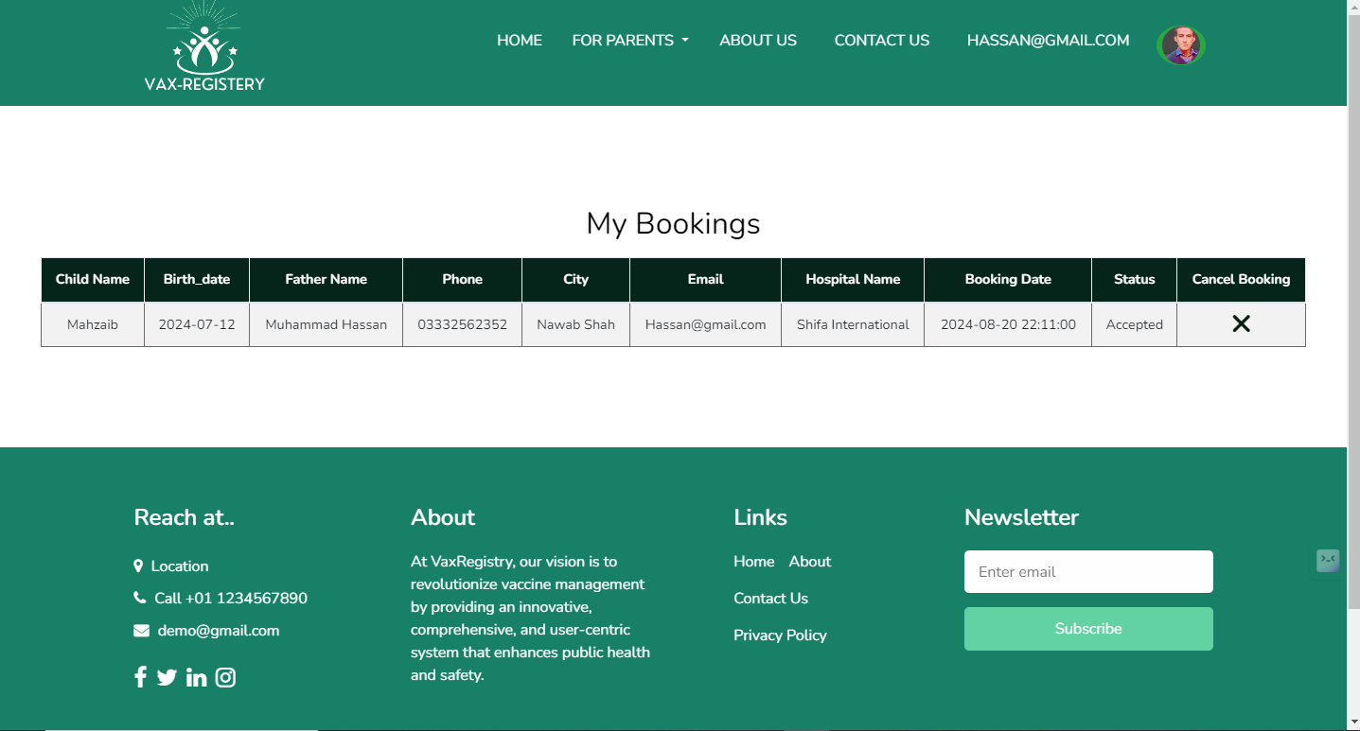

Parents Child’s Vaccination Dates:

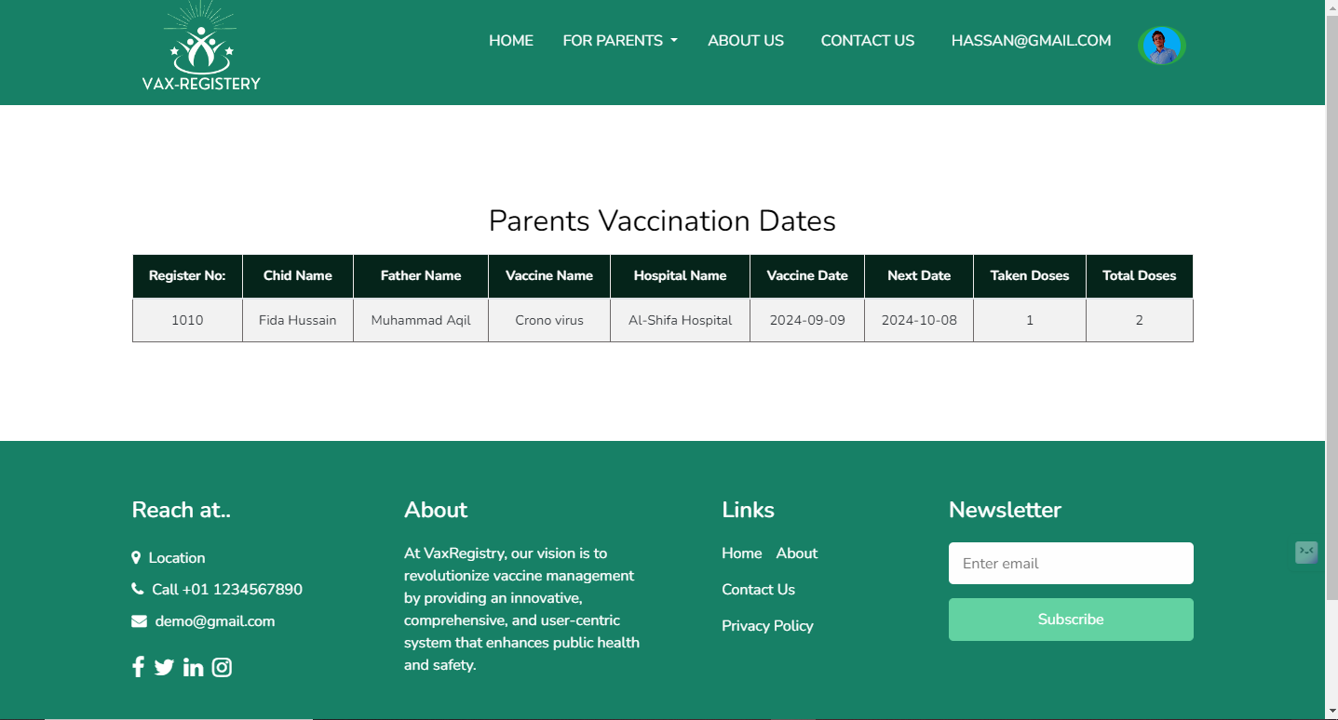 This is the all information about semester end project: